Smart Water Pump Control(Using led as altenative):

#include "BluetoothSerial.h"

BluetoothSerial SerialBT;

int trigpin=2;

int echopin=3;

int led=7;

void setup() {

pinMode(trigpin,OUTPUT);

pinMode(echopin,INPUT);

pinMode(led,OUTPUT);

Serial.begin(115200);

Serial.println("The device has started, now you can pair it with bluetooth!");

}

void loop() {

if (Serial.available()) {

SerialBT.write(Serial.read());

}

if (SerialBT.available()) {

SerialBT.write(SerialBT.read());

}

char a= SerialBT.read();

if(a == 0){

digitalWrite(7,LOW);

Serial.println("led off");

}

else if(a == 1){

digitalWrite(11,HIGH);

Serial.println("led on");

}

digitalWrite(trigpin,HIGH);

delay(1000);

digitalWrite(trigpin,LOW);

int duration = pulseIn(echopin,HIGH);

int dis = duration \* 0.0343/2;

Serial.println("The distance is:");

Serial.println(dis);

SerialBT.write(dis);

delay(100);

}

BLOCKS USED FOR APPLICATION:  
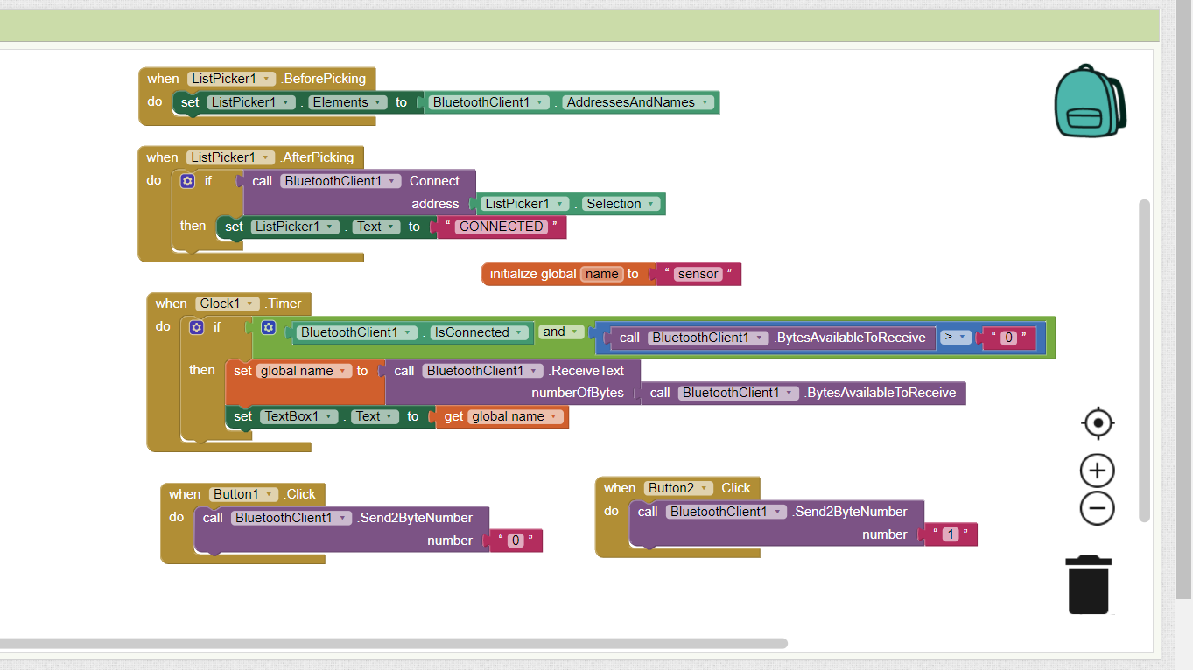

MOBILE APPLICATION:

